**Q1 (50marks): Simulate the behavior of an enhanced Two-Channel Transparent Telerobotic Architecture (𝐶5 = −1, 𝐶6 = 100, 𝐶4 = 0) fo 60 seconds, considering the following parameters:**

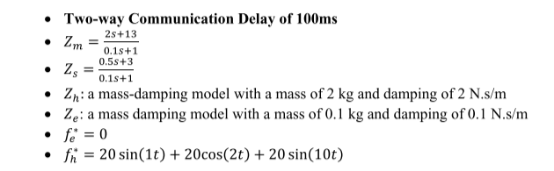

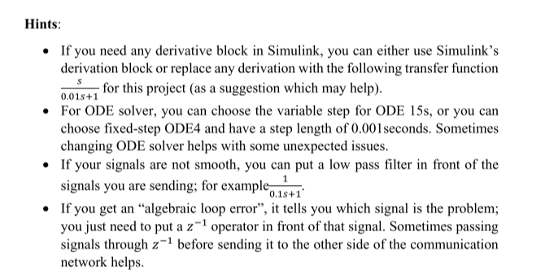

1. **What is Zto of this system? What is the hybrid matrix of the system?**

In an ideal transparency scenario,

1. **Plot the Velocity of the leader robot versus the Velocity of the follower robot. Also, plot the interactive Force (𝐹ℎ) at the leader robot felt by the user versus the Force at the environment side (𝐹𝑒). Compare, evaluate, and discuss the transparency and performance of the system (Force tracking and Velocity tracking).**

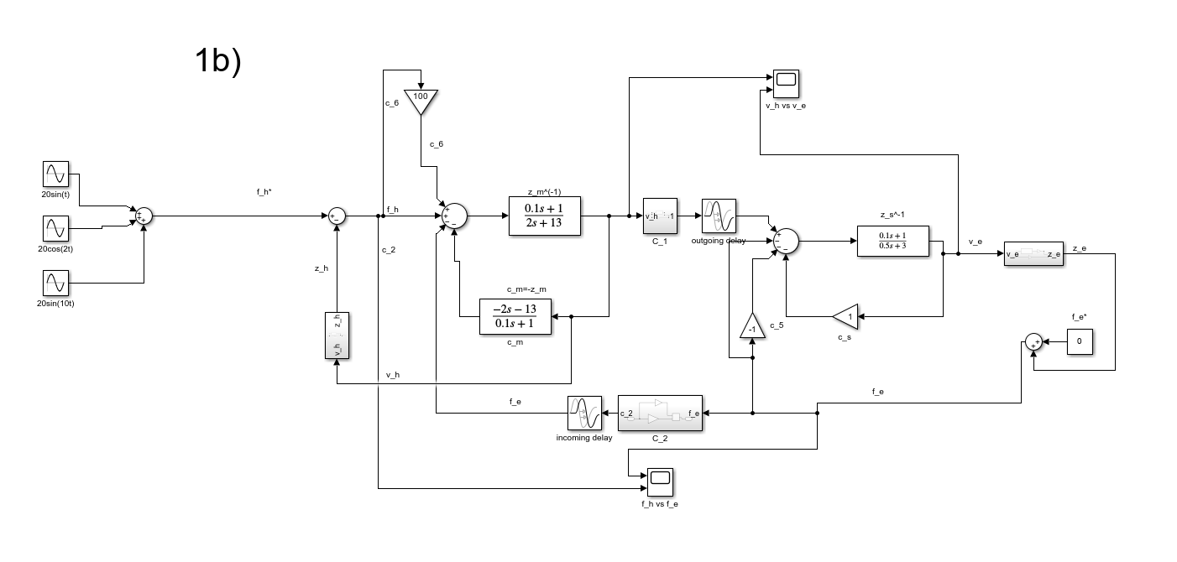

Velocity tracking

vs

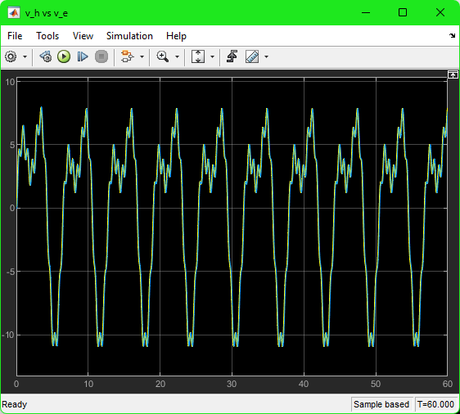

Force tracking

vs

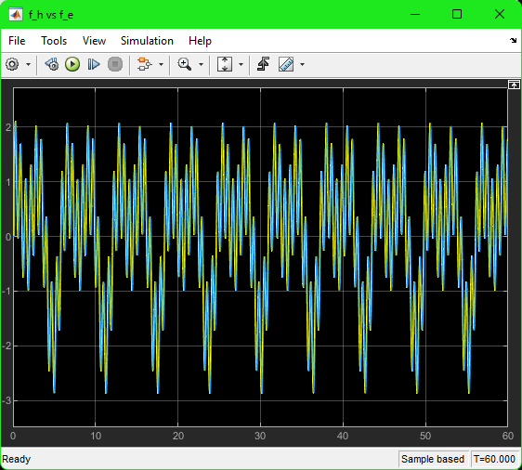

**Compare, evaluate, and discuss the transparency and performance of the system (Force tracking and Velocity tracking).**

As seen in the graphs above, is tracking (same trajectory just shifted by a slight delay) as well as is tracking (same trajectory just shifted by a slight delay). This shows that the system has achieved transparency. This is expected to happen because we have configured the model to match the ideal scenario where you have kinematic correspondence ( = ) as well as ideal force response ( = ) with the exception of a delay in the curves. The system performs according to expectation because there is no echo on follower and leader side, which leads to acceptable force tracking as well as acceptable velocity tracking (ideal case for a scenario with a delay).

1. **Is the system stable? If yes, based on the material in the course, mathematically explain why it is stable. If it is not Stable, explain why it is unstable.**

In order to prove stability, we can use Nyquist Stability Theory. The theory is given below

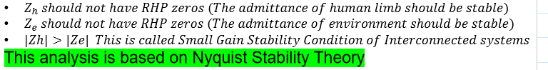

Since the zeros of are not in the RHP, we can conclude that the first condition is satisfied.

Since the zeros of are not in the RHP, we can conclude that the second condition is satisfied.

For the third condition,

Therefore, we can conclude that the third condition has been satisfied. **The system is stable.**

1. **Now replace 𝑍𝑒 with a mass damping model with a mass of 10 kg and damping of 10 N.s/m, Repeat (B), and (C). If the system is unstable, scale down the Force received from the environment, after the communication, at the human side, by the factor of (1/6). Will the system be stable? Plot the velocities and forces (Vh, Ve, Fh, Fe) and write if the velocity tracking changed? If the force tracking was changed? So if the system was unstable, is it correct to say that by scaling down the reflected Force, we can make the system stable? And if it was stable, is it correct to say that scaling down does not affect stability? Explain your answers.**

***Before scaling down***

**Plot the Velocity of the leader robot versus the Velocity of the follower robot. Also, plot the interactive Force (𝐹ℎ) at the leader robot felt by the user versus the Force at the environment side (𝐹𝑒). Compare, evaluate, and discuss the transparency and performance of the system (Force tracking and Velocity tracking).**

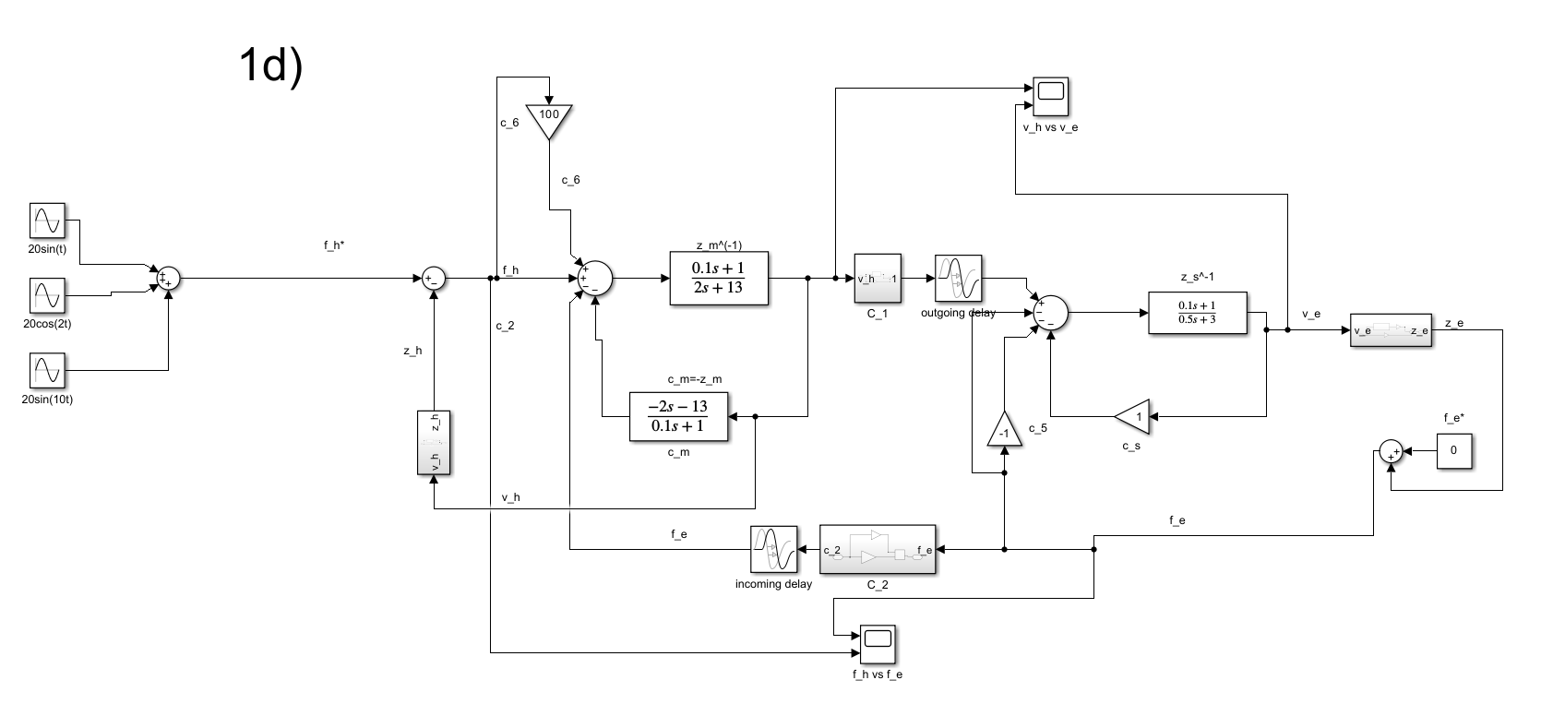

Velocity tracking

vs

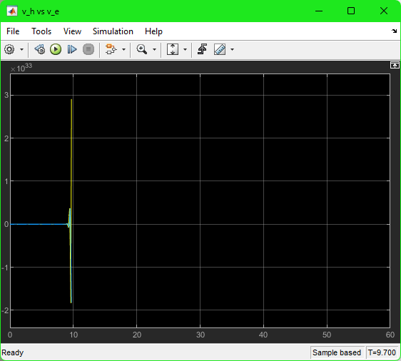

Force tracking

vs

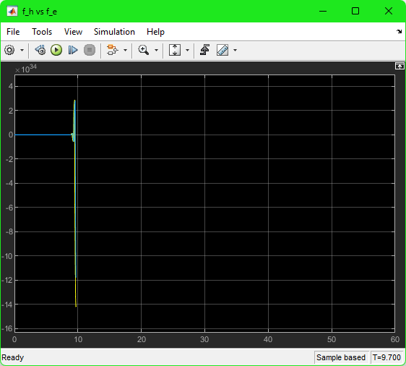

As seen in the graphs above, is tracking (same trajectory just shifted by a slight delay) as well as is tracking (same trajectory just shifted by a slight delay). This shows that the system has achieved transparency. This is expected to happen because we have configured the model to match the ideal scenario where you have kinematic correspondence ( = ) as well as ideal force response ( = ) with the exception of a delay in the curves. The system performs according to expectation because there is no echo on follower and leader side, which leads to acceptable force tracking as well as acceptable velocity tracking (ideal case for a scenario with a delay).

**Is the system stable? If yes, based on the material in the course, mathematically explain why it is stable. If it is not Stable, explain why it is unstable.**

In order to prove stability, we can use Nyquist Stability Theory. The theory is given below



Since the zeros of are not in the RHP, we can conclude that the first condition is satisfied.

Since the zeros of are not in the RHP, we can conclude that the second condition is satisfied.

For the third condition,

Therefore, the third condition has shown to have failed the satisfaction criteria. **The system is unstable.**

***After Scaling down***

**If the system is unstable, scale down the Force received from the environment, after the communication, at the human side, by the factor of (1/6). Will the system be stable? Plot the velocities and forces (Vh, Ve, Fh, Fe) and write if the velocity tracking changed? If the force tracking was changed? So if the system was unstable, is it correct to say that by scaling down the reflected Force, we can make the system stable? And if it was stable, is it correct to say that scaling down does not affect stability? Explain your answers.**

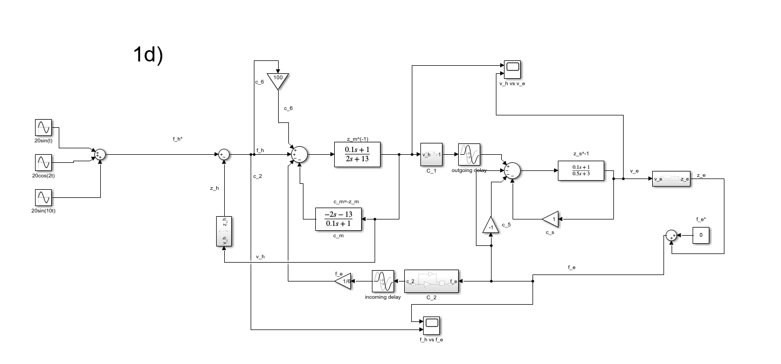

Velocity tracking

vs

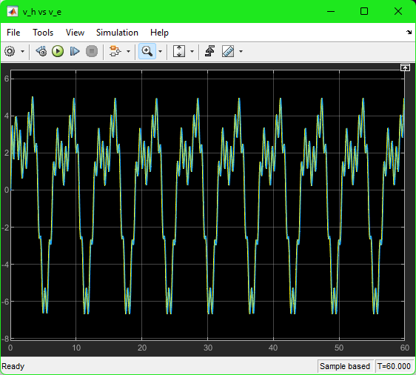

Force tracking

vs

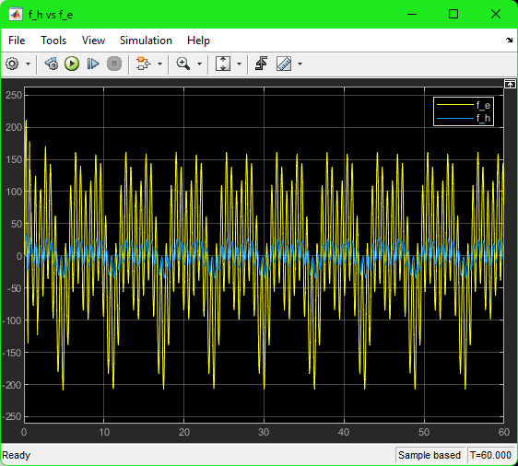

As seen in the graphs above, is not tracking (similar trajectory shifted by a slight delay and different magnitude) but we do observe tracking (same trajectory just shifted by a slight delay). This shows that the system achieves partial transparency. The system performs according to expectation because the force tracking’s magnitude is being reduced and velocity tracking’s magnitude remains the same (only a shift as a result of the delay), which leads to acceptable velocity tracking (ideal case for a scenario with a delay) but unacceptable force tracking.

**So if the system was unstable, is it correct to say that by scaling down the reflected Force, we can make the system stable? And if it was stable, is it correct to say that scaling down does not affect stability? Explain your answers.**

In order to prove stability, we can use Nyquist Stability Theory. The theory is given below



Since the zeros of are not in the RHP, we can conclude that the first condition is satisfied.

Since the zeros of are not in the RHP, we can conclude that the second condition is satisfied.

For the third condition,

Therefore, we can conclude that the third condition has been satisfied. **The system is stable. We can then conclude that scaling down does affect stability as we made an unstable system stable by scaling down.**

1. **Now, for the system plotted in (B), imagine the sensor measuring Fe has some additive noise. You can add the additive noise to Fe* for this generate noise using a random number generator in Simulink** [**(click here for the link).**](https://www.mathworks.com/help/simulink/slref/randomnumber.html?searchHighlight=Random%20Number%20Block&s_tid=srchtitle) **So Fe* is not zero anymore (only for (E)); instead, we use Fe* to add the noise. Plot velocity and force tracking of your system (Vh, Ve, Fh, Fe). You should see the effect of added noise in either velocity tracking or Force tracking, or both. Give a suggestion for reducing the effect of noise, implement your suggestion, and simulate and plot the velocities and forces. Does it work?**

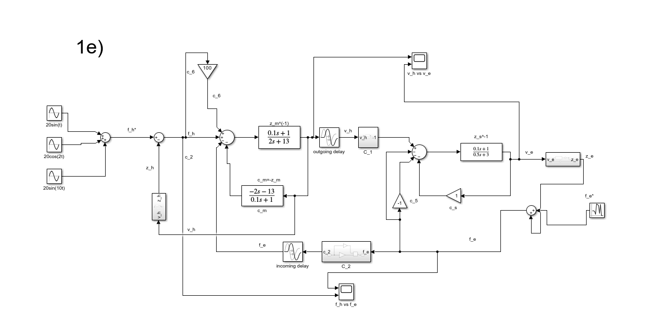

Velocity tracking

vs

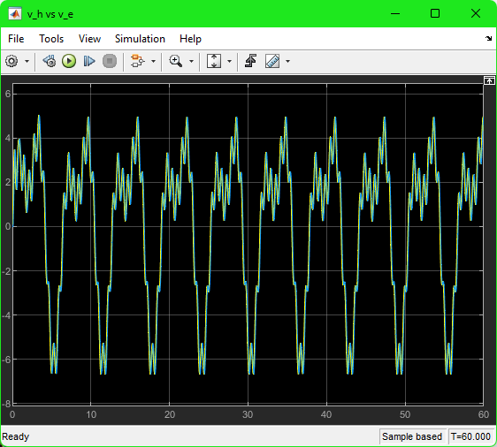

No effects of noise on velocity tracking is seen on the graph of vs because it is the same as the velocity tracking graph from part 1B.

Force tracking

vs

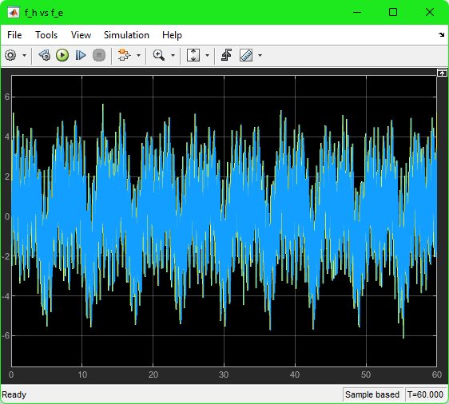

Substantial effects of noise on force tracking is seen on the graph of vs because it is not the same as the force tracking graph from part 1B and has random noise being added.

**Give a suggestion for reducing the effect of noise, implement your suggestion, and simulate and plot the velocities and forces. Does it work?**

Add a low-pass filter to remove high frequency waves.

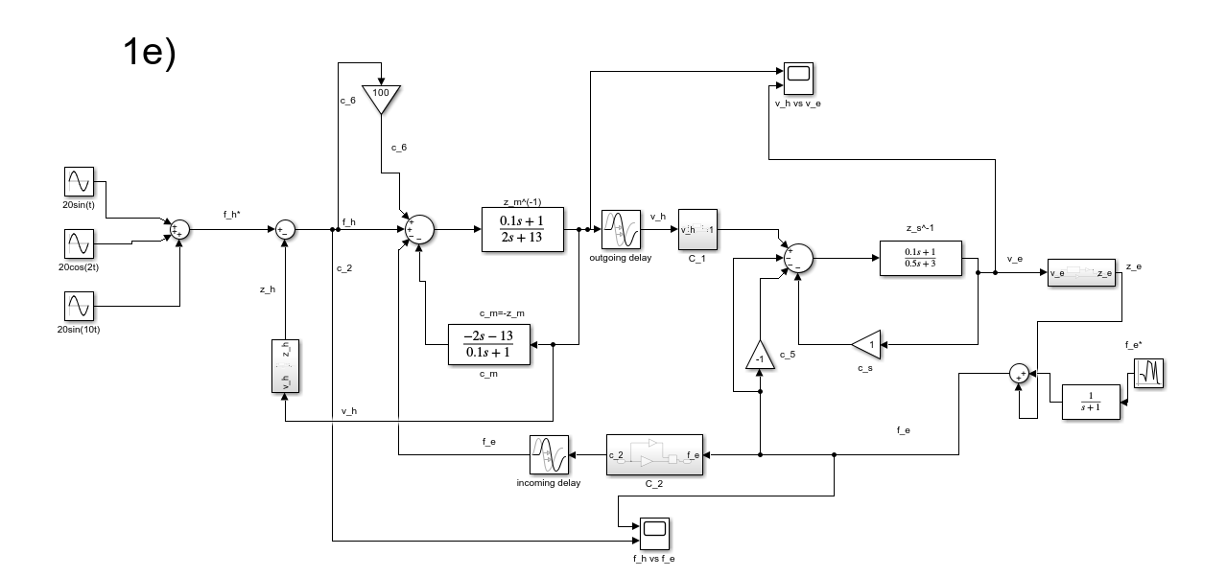

Velocity tracking

vs

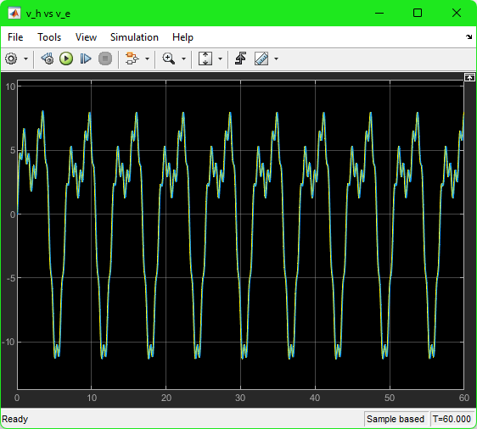

No change is seen on the graph of vs so it does work.

Force tracking

vs

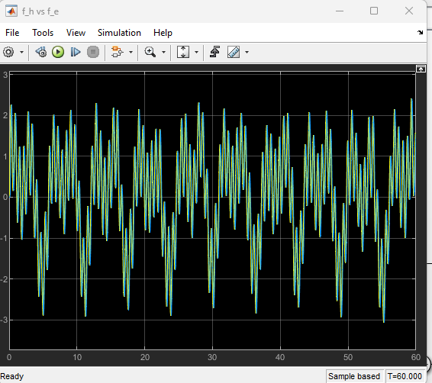

A major change is seen on the graph of vs where we no longer see the effect of the noise. We can now see that vs is identical to the force tracking graph from part 1B.

Q2 (50marks):

1. **Using integral passivity, mathematically prove that a damper ( 𝑓(𝑡) = 𝐵 𝑉(𝑡), when F is force V is Velocity, and B is the damping coefficient) is passive, when input is Velocity and output is Force.**
2. **Using integral passivity, can you prove that the spring is also passive when input is Force and output is Velocity.**

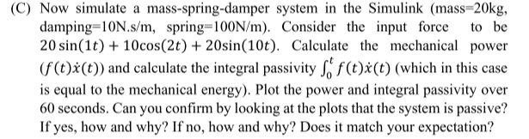

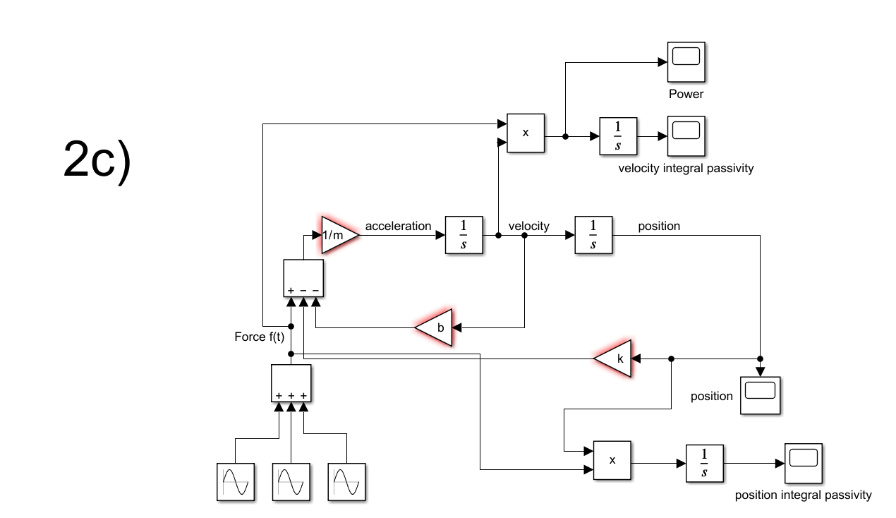

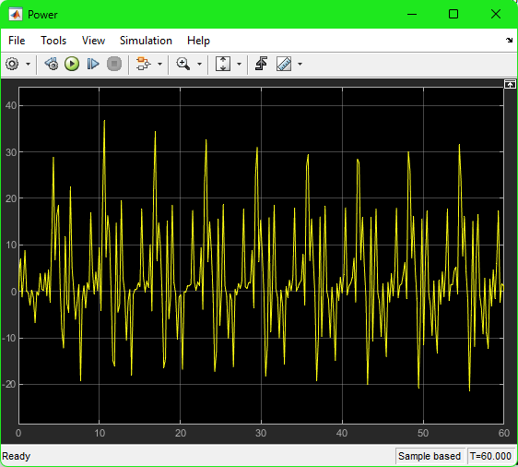

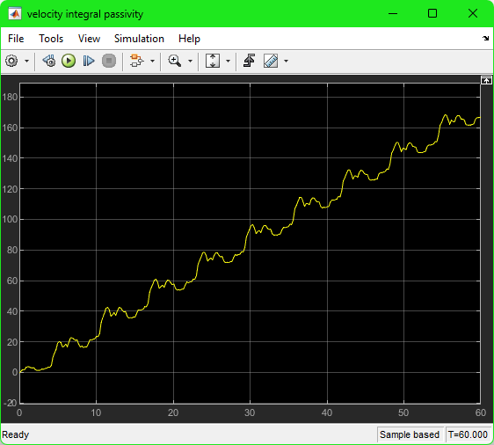

**Plot the power and integral passivity over 60 seconds. Can you confirm by looking at the plots that the system is passive? If yes, how and why? If no, how and why? Does it match your expectation?**

As seen in the integral passivity graph above, the integral of power (Force*velocity), energy, is positive. This means that the system is passive (we are currently in the time domain). This matches our expectation because we have a simple mass spring damper system that can be easily shown to be passive in force-velocity domain, where velocity is the output and force is the input.

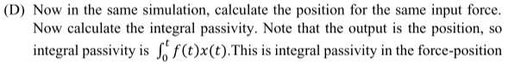

**domain (when your output is position), which is different from the mechanical definition of energy. Plot the integral passivity for the output of position. So based on this integral passivity, can you say the system is passive? If yes, how? If no, why? And how/why this result is different from the previous one (when The output was Velocity) if it is different?**

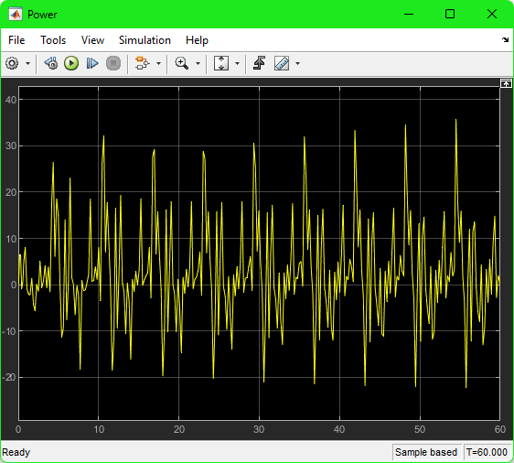

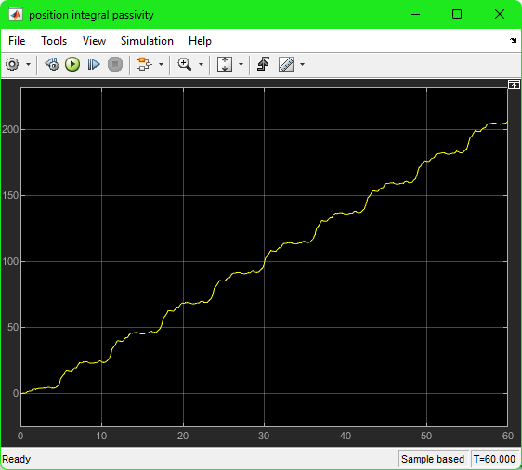

**So based on this integral passivity, can you say the system is passive? If yes, how? If no, why? And how/why this result is different from the previous one (when The output was Velocity) if it is different?**

As seen in the integral passivity graph above, the integral of Force*position is positive. This means that the system is passive (we are currently in the time domain). This matches our expectation because we have a simple mass spring damper system that can be easily shown to be passive in force-position domain, where position is the output and force is the input. The result is not different from the previous one because both integral passivity graphs are positive and increasing showing that the system is passive.



1. **Based on the following formulations (positive realness):**
2. 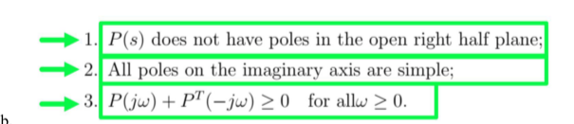
3. **Can you mathematically (and using positive realness (given above) show that the system can be non-passive if the output is Position? Provide your mathematical derivations.**

For output position,

Condition 1: we need to find poles of P(s) =

Therefore, there are no poles in the open right half pane, so this condition is satisfied.

Condition 2: there are no poles on the imaginary axis, therefore this condition is satisfied.

Condition 3:

Passivity in admittance = Passivity in impedance

Since **we know that it fails Llewellyn’s criterion and is non-passive.**

**Can you mathematically (and using positive realness (given above) show that the system can be non-passive if the output is Position? Provide your mathematical derivations.**

For output velocity,

Condition 1: we need to find poles of P(s) =

Therefore, there are no poles in the open right half pane, so this condition is satisfied.

Condition 2: there are no poles on the imaginary axis, therefore this condition is satisfied.

Condition 3:

Passivity in admittance = Passivity in impedance

Since **we know that it passes Llewellyn’s criterion and is passive.**